Technical Architecture:
Project Design Phase-II Technology Stack (Architecture & Stack)

Date | 01 November 2025
Team ID | 69c0be5ec71a9ebd6a51912e
Project Name | Streamlining Ticket Assignment for Efficient Support Operations
Maximum Marks

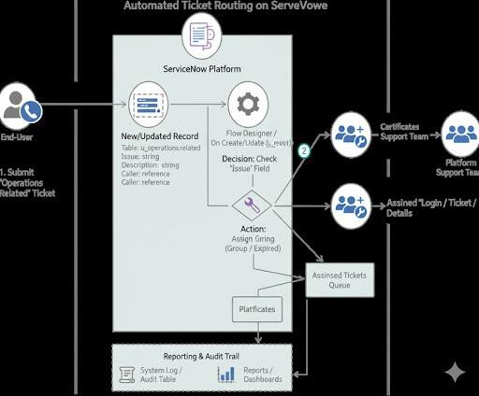

Table-1 : Components & Technologies:

S.No | Component | Description | Technology
1. | User Interface | End-user submits a ticket via a ServiceNow form. Support agents view tickets in lists/queues. | ServiceNow Web UI (Forms, Lists)
2. | Application Logic-1 | Triggers when a record is created/updated on the Operations related table and checks the 'Issue' field. | ServiceNow Flow Designer (Trigger)
3. | Application Logic-2 | Updates the 'Assigned to group' field on the record based on the 'Issue' (e.g., to 'Certificates' or 'Platform'). | ServiceNow Flow Designer (Action: Update Record)
4. | Application Logic-3 | (Optional) Sends a notification to the assigned group that a new ticket is in their queue. | ServiceNow Notifications
5. | Database | Stores the new tickets, the support groups, and user data. | ServiceNow Custom Table (u_operations_related), Group Table (sys_user_group)
6. | Cloud Database | Managed by ServiceNow cloud backend, hosts the custom table and flow definitions. | ServiceNow Cloud Database
7. | File Storage | Minimal use; stores execution logs for the flows and audit history for the tickets. | ServiceNow system logs, Flow execution details
8. | Machine Learning Model | Not applicable. (Future scope could use ML for predictive assignment). | -
9. | Infrastructure (Server / Cloud) | Hosted and managed on the ServiceNow SaaS platform. | ServiceNow Cloud (SaaS)

Table-2: Application Characteristics:

S.No | Characteristics | Description | Technology
1. | Open-Source Frameworks | Not applicable (ServiceNow is proprietary). | -
2. | Security Implementations | Role-based access control (Platform_role, Certificate_role) and ACLs restrict read/write access to the Operations related table. | ACLs (Access Controls), System Security (Roles)
3. | Scalable Architecture | The solution is highly scalable; new routing rules or groups can be added via Flow Designer with no code. | ServiceNow Cloud Architecture,  Flow Designer
4. | Availability | Highly available with ServiceNow cloud hosting and redundant instances. | Load-balanced ServiceNow Instances
5. | Performance | Optimized via efficient, modern Flow Designer logic (rather than older scripts) and indexed tables. | Flow Designer, Indexed Tables

